**UX00. Home Page (Portal Opening View)**

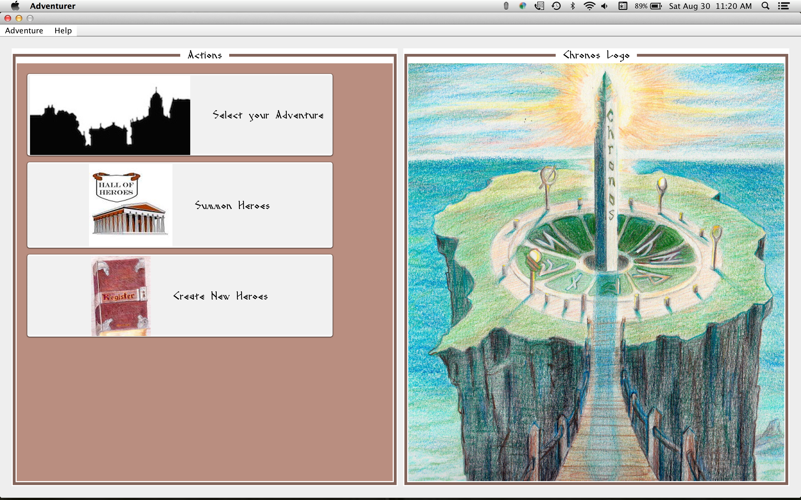

*Adventurer* starts with the a window frame and menu bar on top, three large buttons on the right, and the Chronos logo in the image panel. Note the *Adventurer* name in the title bar.

MENUBAR:

Adventurer -> Quit: Terminates the program.

Help -> Help: Displays general help in a resizeable, moveable window.

F1 key (Help): Displays general help in a resizeable, moveable window.

Help -> About: Displays dialog for program details and credits.

BUTTONS:

**Select Your Adventure**: Displays a dropdown list of selectable adventures. Currently only the default adventure is available. See Use Case Open Adventure.

**Summon Heroes (Dormitory)**: Save or retrieve an existing Hero. See Use Case Summon Hero.

**Create New Hero**: Creates a new Hero and saves it in the Dormitory. See Use Case Create Hero.